2018
Gbenga Idris
iHealth Nigeria GSFM
1/1/2018
iHealth Admin Guide


CONTENT

- INTRODUCTION
IHealthGSFM – Nigeria’s premiere meeting point of quality health, good technology and easy access. Our core aim is to make quality healthcare more accessible to you by providing a holistic healthcare services that use technology to give you this access, via our website (www.ihealthgsfm.com) and other relevant websites that provide quality healthcare services from around the globe.

The document will provide administrative guide on how to use the website effectively. If you have any question that is not covered in this guide, please contact us using the developer via email: idrisgbenga@outlook.com

- DASHBOARD
Note: for details on how to access the website and login kindly visit the user guide document.
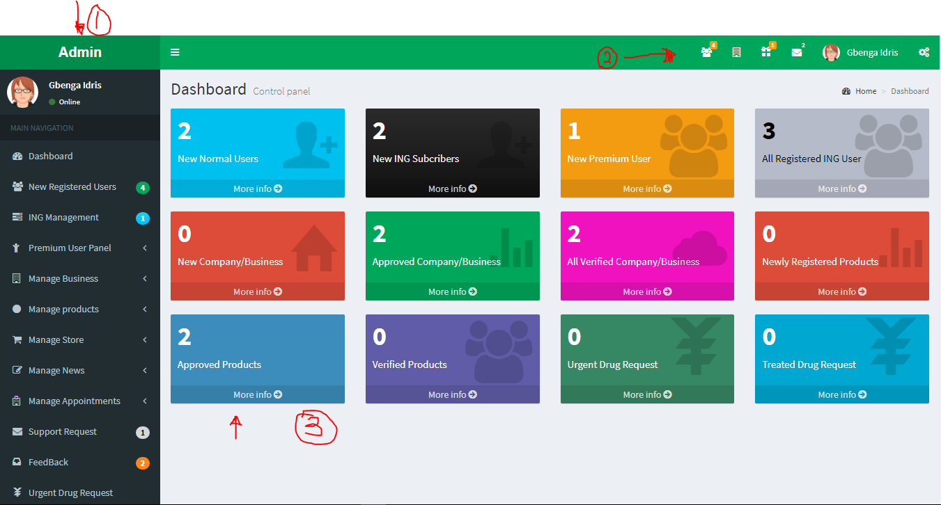
Fig. 1 Admin Dashboard
The admin dashboard as shown in fig. 1 is divided into three different section.
- This is the side bar that the contain links to different pages.
- This is the notification status bar
- This is the information section which allows admin to access some basic information without much navigation.

- SIDE BAR
3.1 NEW REGISTER USERS
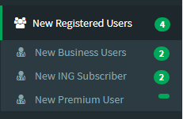 Fig. 2 Dashboard Side Bar.
This sections allows the admin to view new user registrations and act appropriately. The number to the right is a counter that show how many new registration is available.
NOTE: for each of the category newly registered users admin will have to click the appropriate link to perform the following functions;
- Click the “Approve or mark as seen button” to ratify that newly registered user information has been viewed.
- For Premium User: Admin will click the “Approve payment button” to ratify that premium user payment has been received and confirmed.

  - ING MANAGEMENT
This section allows admin to manage iHealth Networking Group member’s subscriptions. As show in fig. 3, this section has 5 other link as submenus
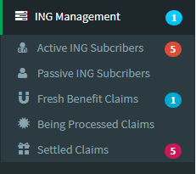Fig. 3. ING Management

- Active ING Subscribers: this contain details of iHealth Networking Group Members who have completed registration by making payments
- Passive ING Subscribers: this contain details of iHealth Networking Group members whose payment has not yet been confirm.
NOTE:
- Once payment is made by client(s) the admin should confirm such payment from the bank account, once the client(s) payment is confirmed. The admin should also visit the “passive ING subscribers” page to effect the confirmation on the page by selecting the specific client(s) and then click the “Approve Payment” button as shown in fig. 4.
- Once the “Approve Payment” button is clicked the action cannot be reverted. So admin should be ensured that the client payment has been confirmed manually from the bank account, before carrying out any action on this page.

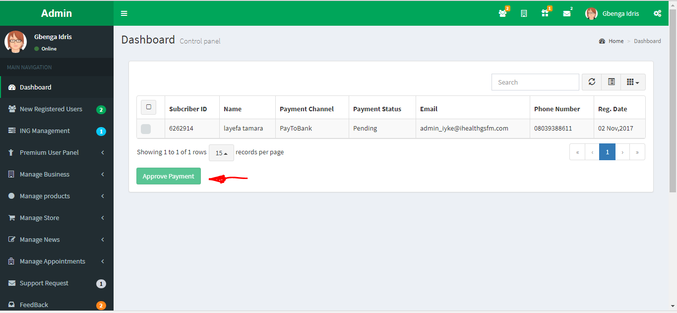
Fig. 4. Passive ING Subcribers Page

- Fresh Benefit Claims: this section allows admin to check and process fresh benefit claim from ING users as shown in fig. 5. Admin can click the details button labelled 2 to get label 3. Inorder to process the benefits admin will then click process button labelled 1
NOTE:
- Once the process button is clicked an auto-generated email is sent to the beneficiary of the benefit, letting him/her know the status of his/her request.
- A processing receipt is generated for admin as shown in fig. 6, for filing or documentation purpose.

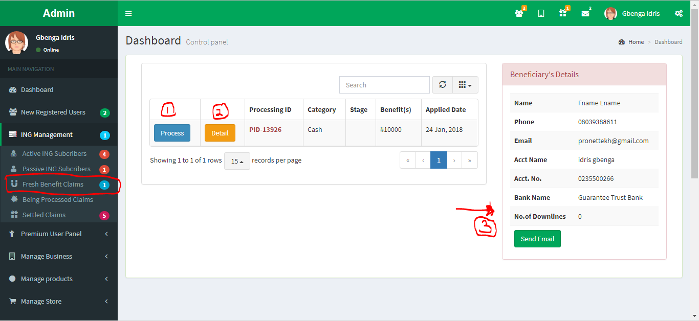
Fig.5, Fresh Benefits claim page
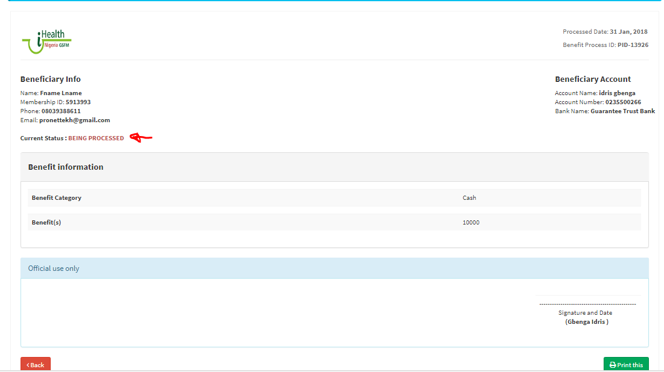
Fig. 6 Benefit Processing Receipt

- Being Processed Claims: this section allow admin to check already being process benefits and mark as settled once the benefits has been completely process (i.e. the beneficiary has received his/her benefits). Admin can either click the “Marks as Settled” button to notify the beneficiary that the benefit claim process has been completed or click the “processing report” button just to generate benefit status report as shown in fig 6.

NOTE:
- Once the “Mark as Settled” button is clicked action cannot be reversed. Hence this button should only be clicked once the beneficiary has receive his/her benefit.
- An email is automatically sent to the beneficiary, updating him/her with the status of his/her request.
- A settled report is generated for admin as shown in fig. 6, for filing or documentation purpose.
- Settled Claims: this allows the admin to view list of already settled benefits, and generate report if necessary.
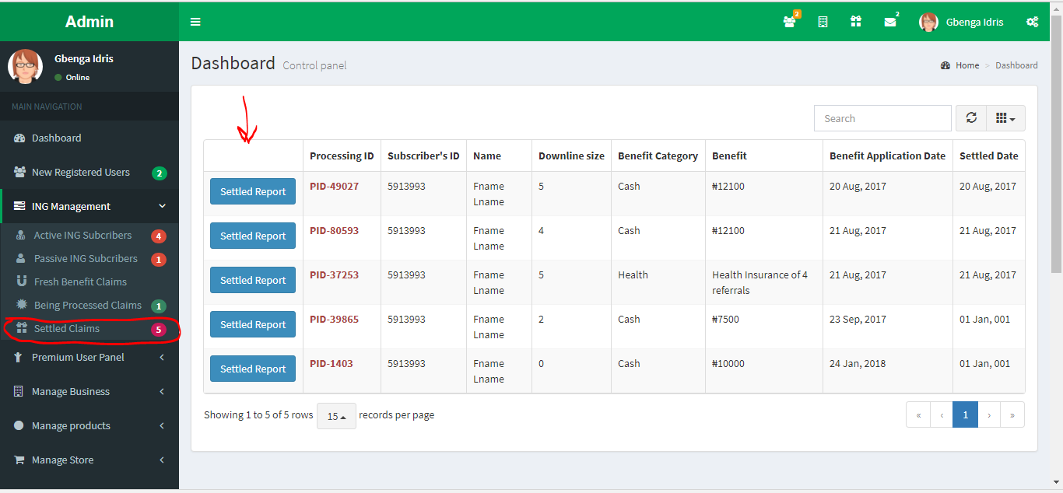
Fig.7. List of settled benefits.

  - PREMIUM USER PANEL
This section allows admin to manage premium user subscriptions. As show in fig. 8, this section has 2 other link as submenus
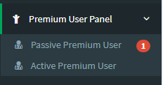Fig. 8. Premium User Panel

- Passive Premium User: this is are premium user whose payment has not yet been confirm. But, once payment has been confirm in the bank accounts Admin can now approve payment has shown in fig. 9.
NOTE: Once the “Approve Payment” button is clicked the action cannot be reverted. So admin should be ensured that the client payment has been confirmed manually from the bank account, before carrying out any action on this page.

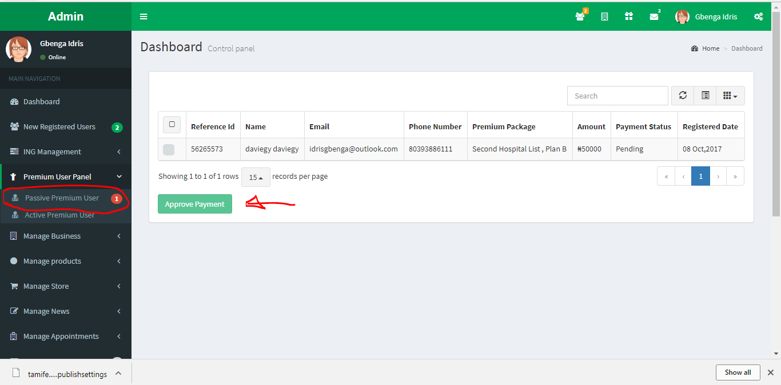
Fig. 9. Passive premium user

- Active Premium User: this shows the list of active premium user whose payment has been confimed.

  - BUSINESS MANAGER
This section allows admin to manage business or services of our user. As shown in fig. 10, this section has 4 other link as submenus
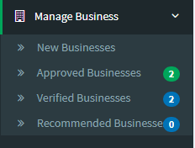Fig. 10. Manage Business
- New Businesses: this section contained information about newly registered businesses or service as shown in Fig. 11. Admin can click the Approve button, in order approve such business.
- Approved Business : this sections show list of approved businesses or services. In this section, admin can also click the verify button to verify such businesses or services.
- Verified Businesses: this sections show list of verified businesses.
- Recommended Businesses: this sections shows list of recommended businesses or services.

NOTE:
- The same explanation goes for the Manage Products.
- Once the Approve or Verify or Recommended button is clicked, the business or service owner receive an email, notifying him or her the status of the business or products

